**Comments, Escape sequences and Print Statements**

Comments

-- A comment is a part of the coding file that the programmer does not want to execute.

-- Rather the programmer uses it to either explain a block of code or to avoid the execution of the specific part of the code while testing.

Single Line Comment

-- To write a comment or make a existing single line code as comment, just add ‘#’ at the start of the line.

-- Click on the desired line and hit ctrl+/

Multi Line Comment

-- To write multi-line comment, you can use ‘#’ at each line or you can use the multi-line string.

Escape Sequence Character

-- To insert the characters that directly cannot be used in a string, we use an escape sequence character.

-- An escape sequence character is backslash ‘\’ followed the character you want to insert.

-- Following is the list of escape sequence characters we can play around with:

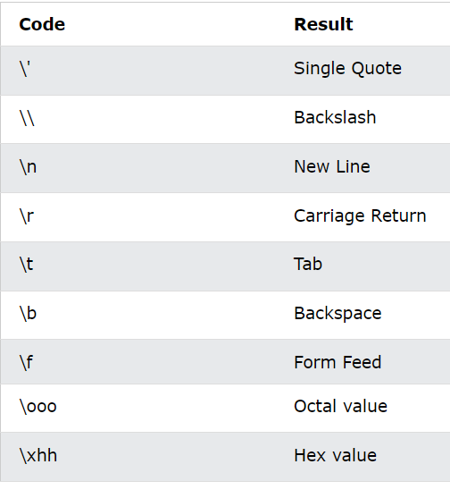

Print Statements

-- The syntax for print statement looks something like this:

> print(object(s), sep=separator, end=end, file=file, flush=flush)

1. object(s) => Any object, and as many as you like,

will be converted to string before printed.

2. sep => Specify how to separate the object, if there is more than one. The default one is ‘ ‘.

3. end => Specify what to print at the end.

4. file => An object with a write method. Default is sys.stdout.